# **Multiclass**

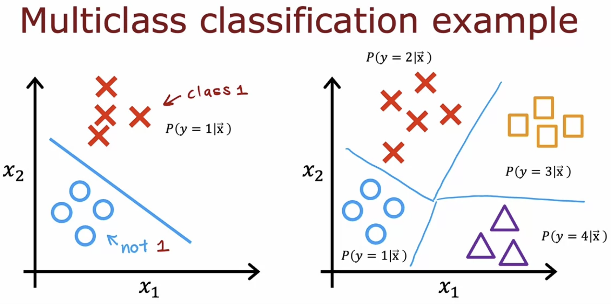

# **SoftMax**

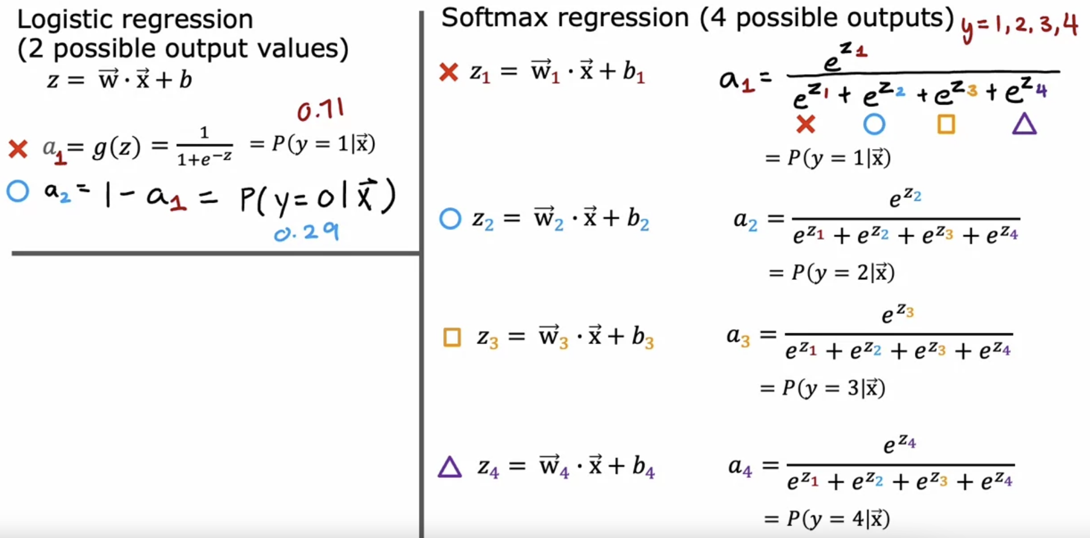

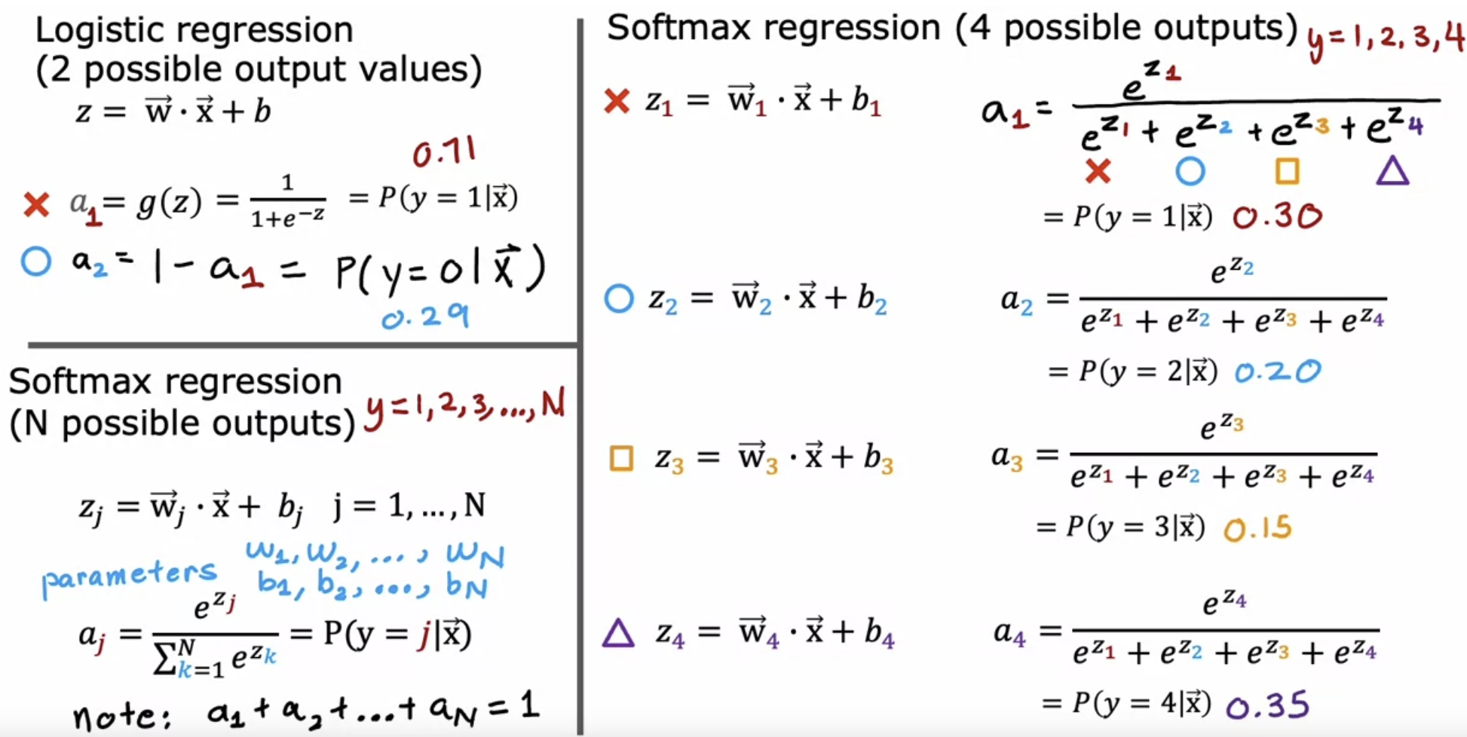

Apply SoftMax regression with n=2, so there are only two possible output classes then SoftMax regression ends up computing basically the same thing as logistic regression.

The parameters end up being a little bit different, but it ends up reducing to logistic regression model.

But that's why the SoftMax regression model is the generalization of logistic regression.

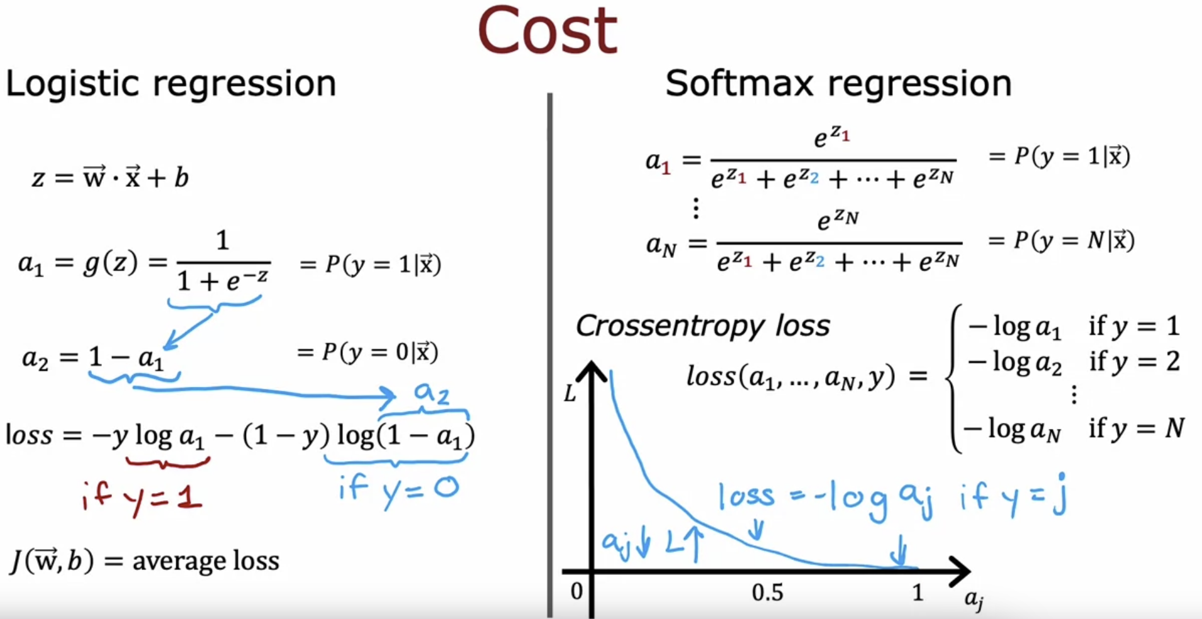

aj and loss are inversely proportional.

If a j was very close to 1, then you beyond this part of the curve and the loss will be very small.

But if it thought, say, a j had only a 50% chance then the loss gets a little bit bigger.

The smaller a j is, the bigger the loss.

This incentivizes the algorithm to make a j as large as possible, as close to 1 as possible.

Because whatever the actual value y was, you want the algorithm to say hopefully that the chance of y being that value was pretty large.

AIM 🡪 aj to make as large as possible, so that the loss is minimized.

For example, if y was equal to 2, you end up computing negative log of a2, but not any of the other negative log of a1 or the other terms here.

# **Neural Network with SoftMax output**

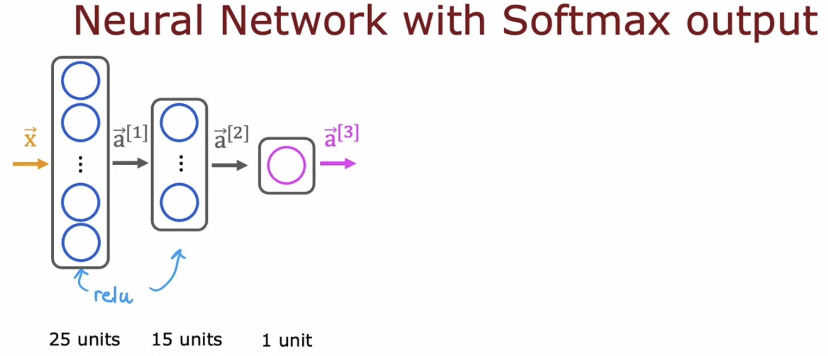

For 2 class

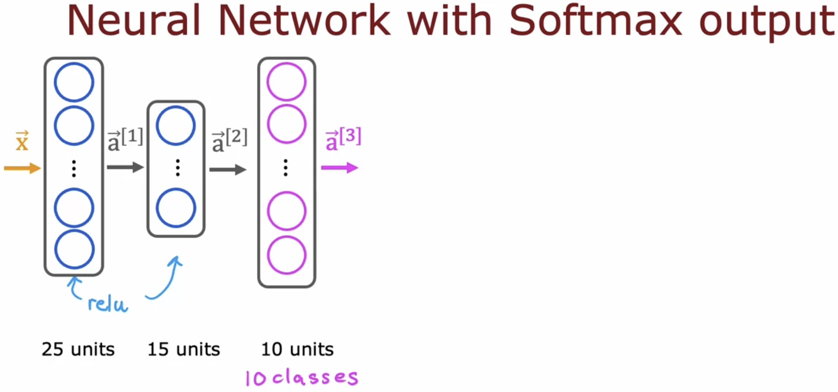

For 10 classes

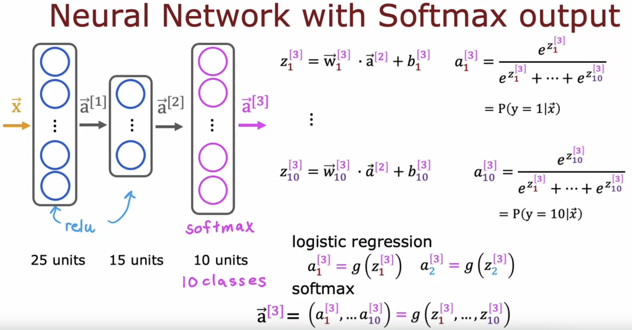

**

## **Argmax function**

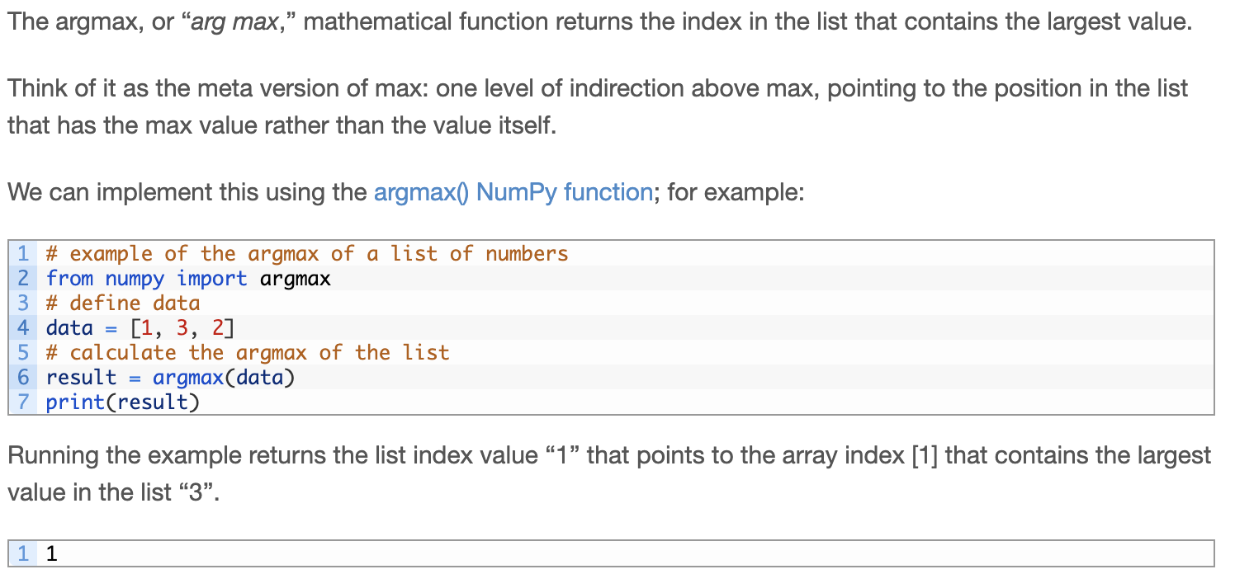

## **SoftMax function**

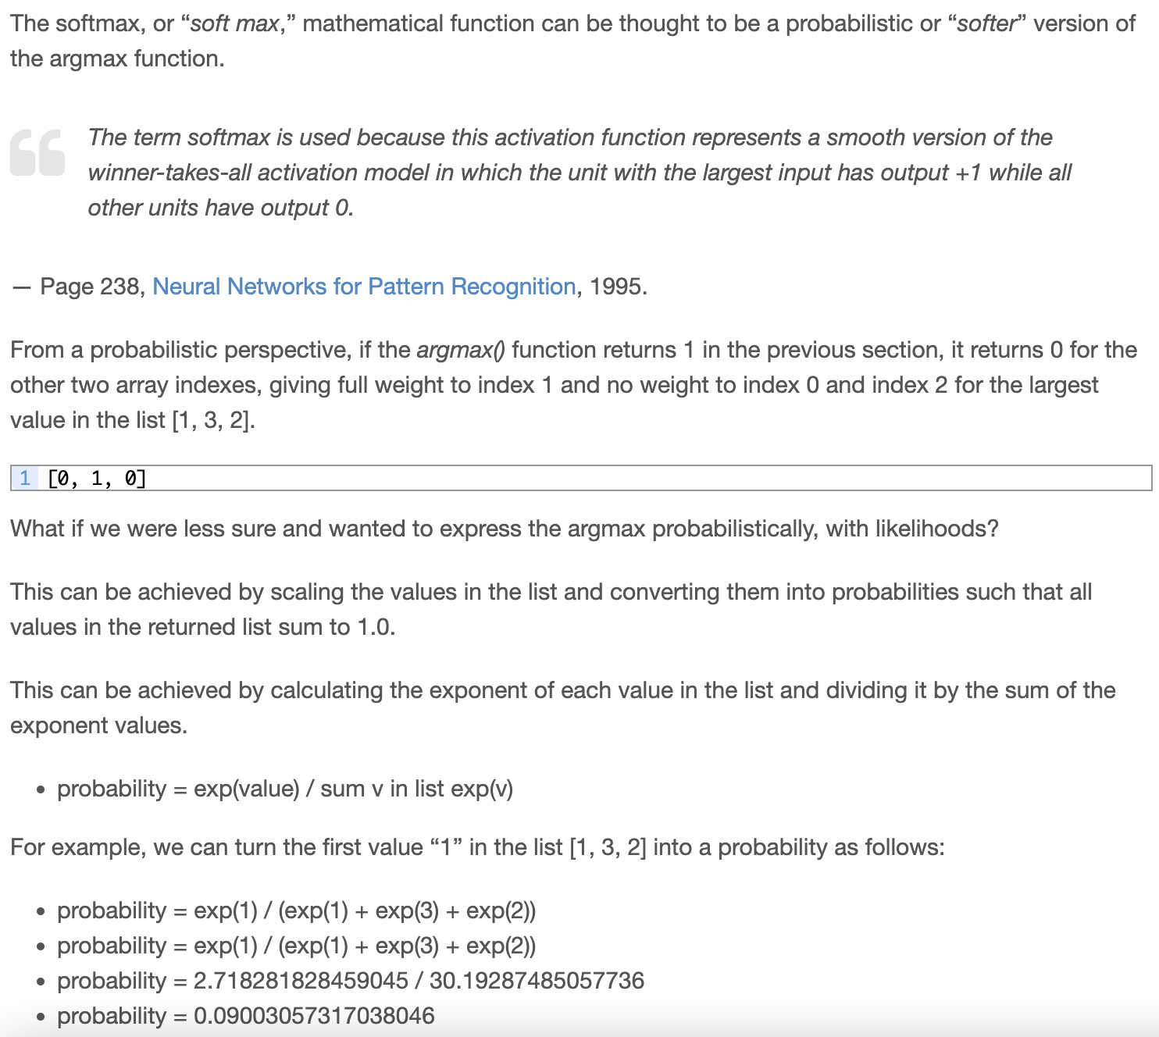

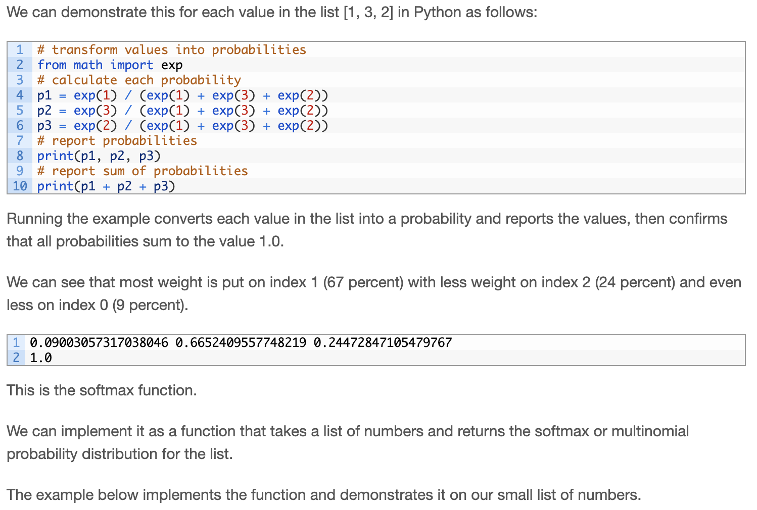

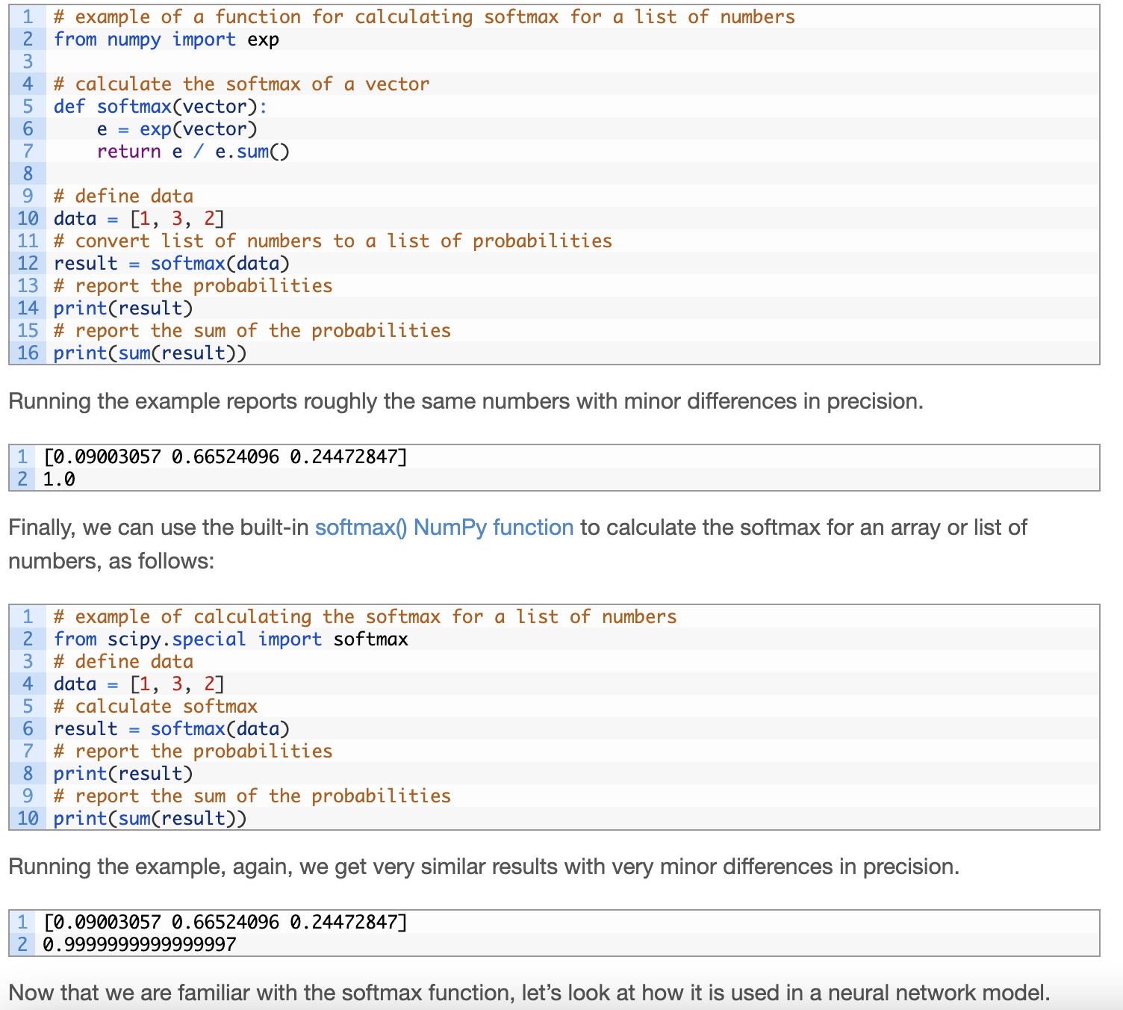

## **SoftMax Activation Function**

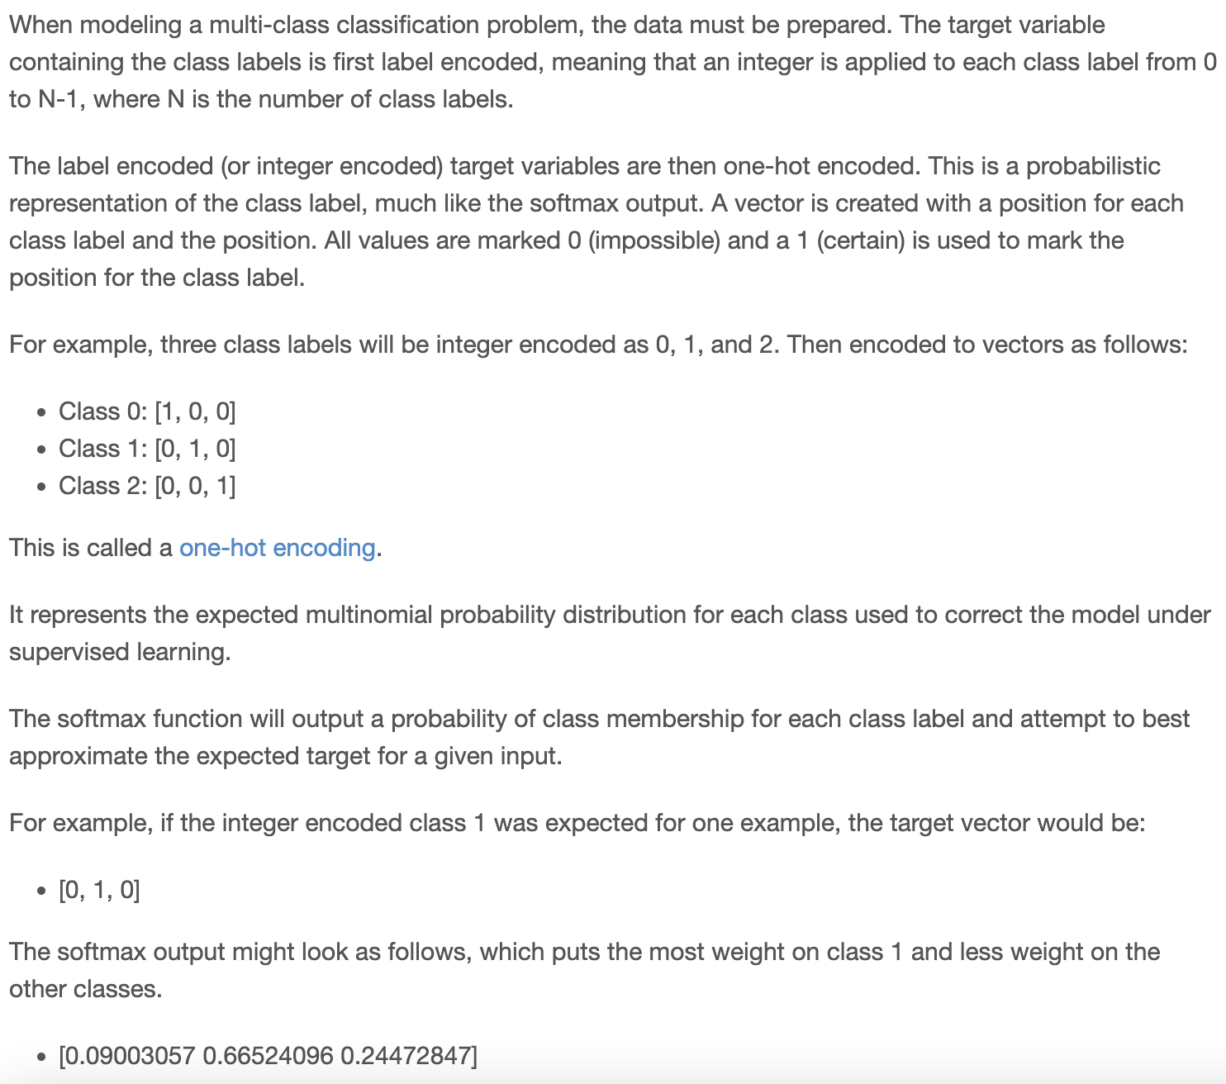

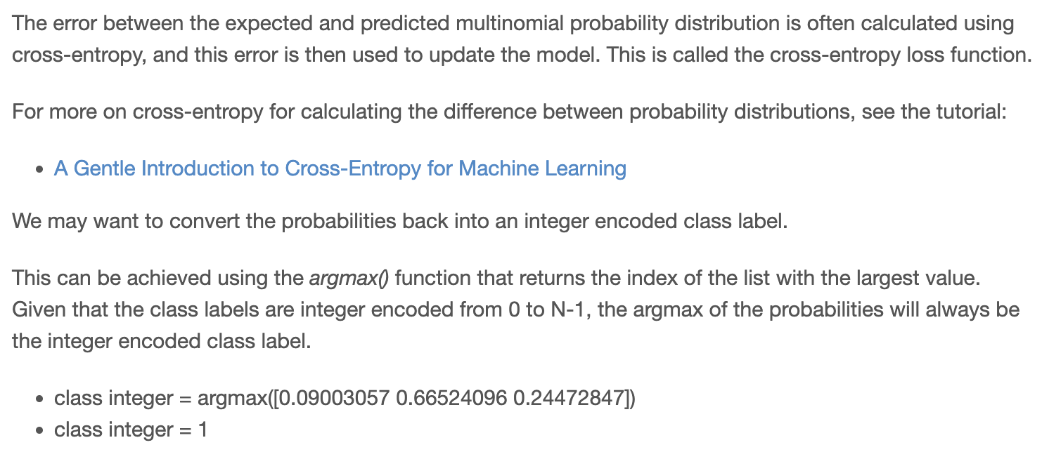

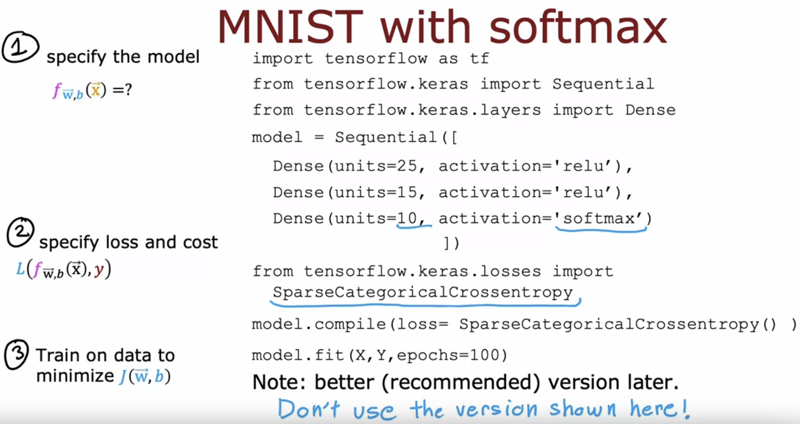

Logistic regression 🡪 Binary Cross Entropy Function

SoftMax regression 🡪 Sparse Categorical Cross Entropy Function

Category refers to, it is still classified y into categories. So it's categorical. This takes on values from 1 to 10.

Sparse refers to that y can only take on one of these 10 values.   
So each image is either 0 or 1 or 2 or so on up to 9. You're not going to see a picture that is simultaneously the number two and the number seven so sparse refers to that each digit is only one of these categories.

Cross Entropy function also called as intensive though the sparse categorical cross entropy loss function.

# **Improved implementation of SoftMax**

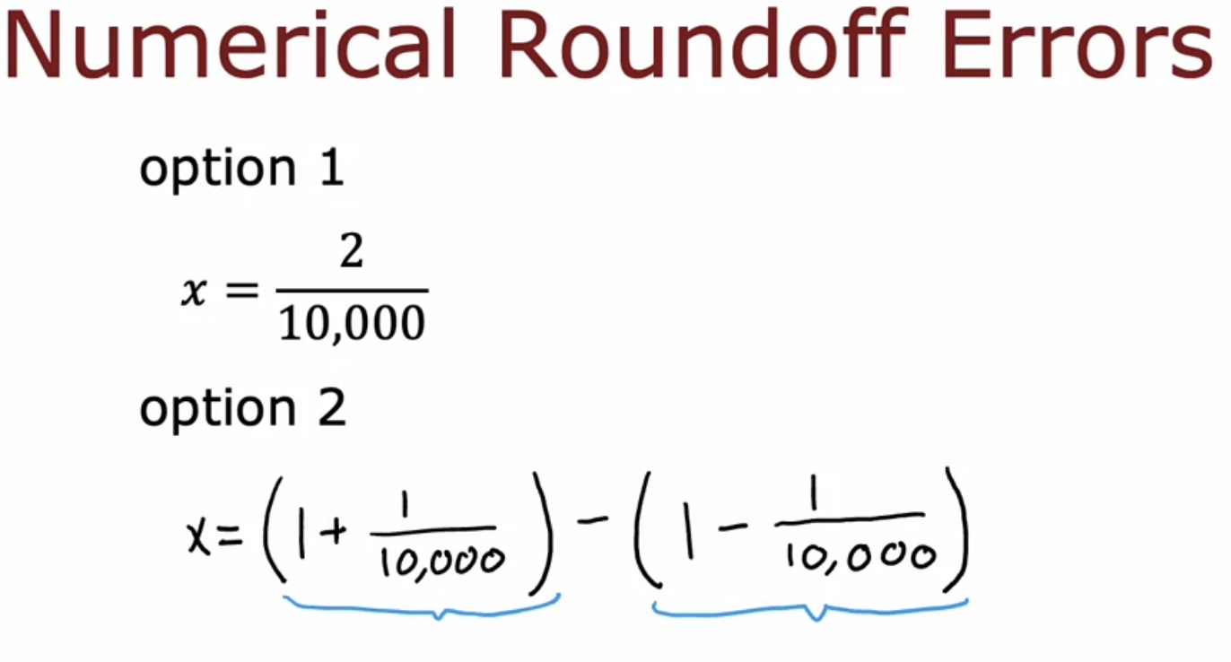

Option-2 also gives the ans

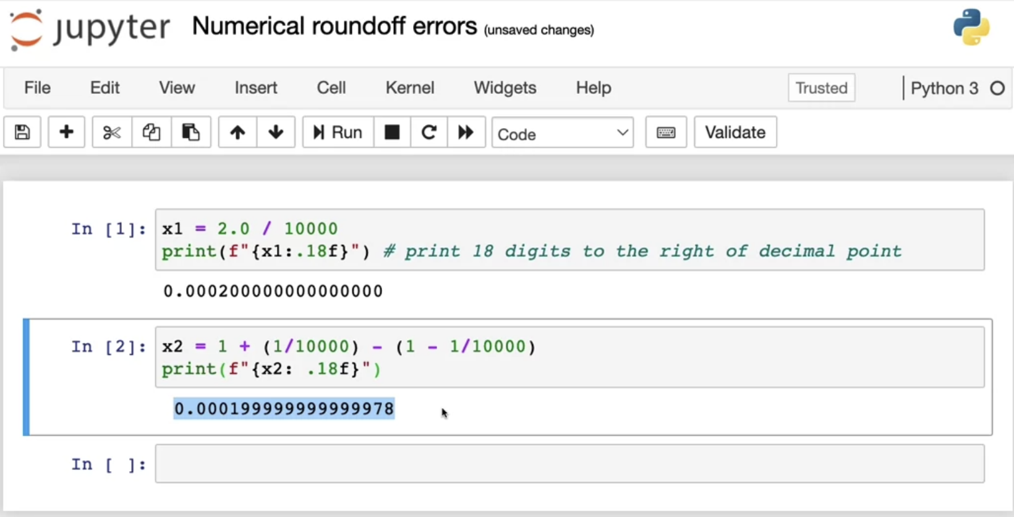

 It just looks a little bit  off this as if there's some round-off error.

Because the computer has only a finite amount of memory to store each number, called a floating-point number in this case, depending on how you decide to compute the value 2/10,000, the result can have more or less numerical round-off error.

## **Applying this technique in Logistic Regression**

General

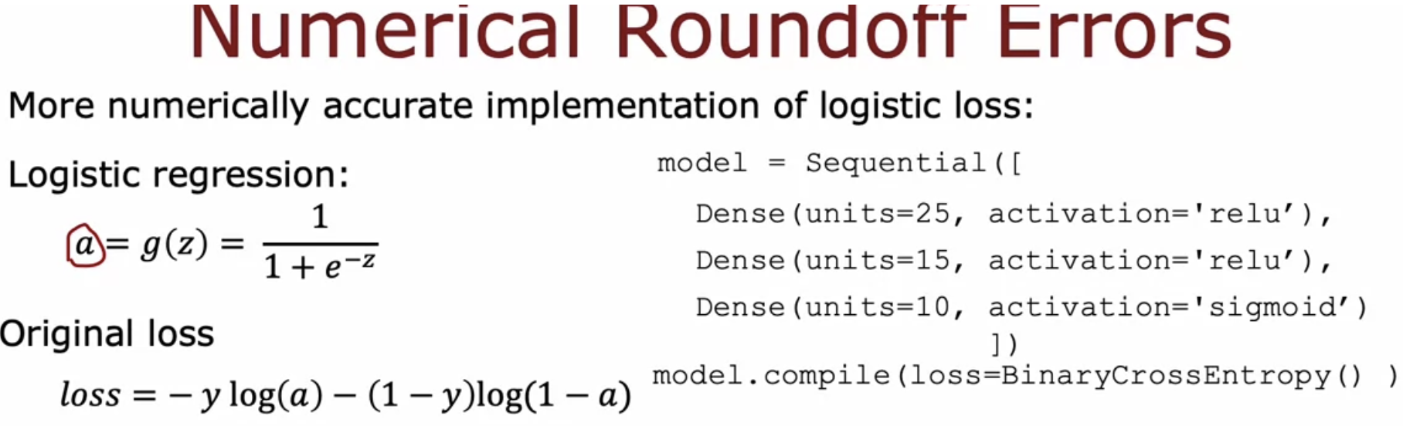

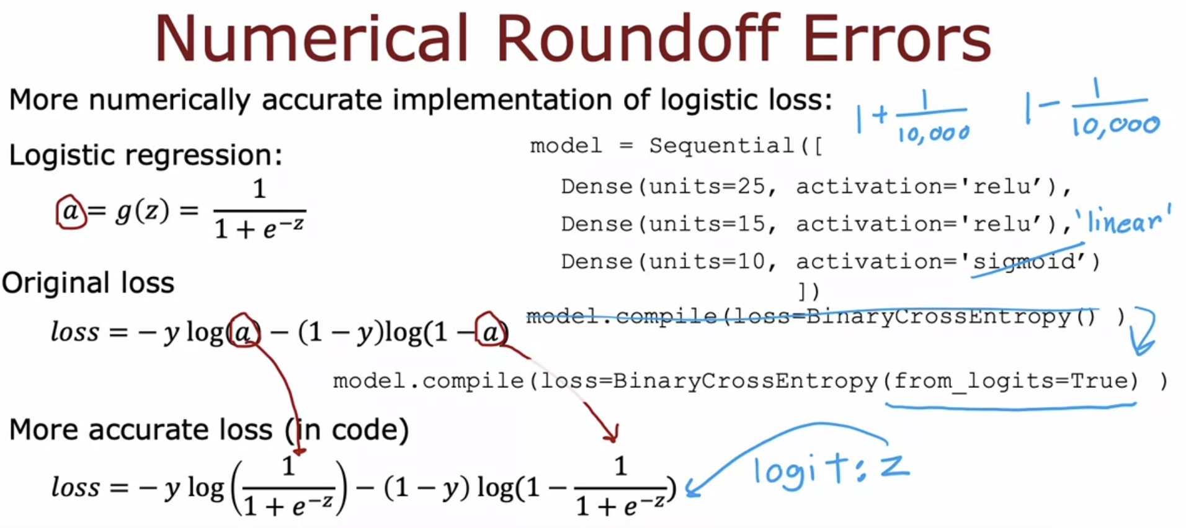

In case you're wondering what the logits are, it's basically this number z. TensorFlow will compute z as an intermediate value, but it can rearrange terms to make this become computed more accurately.

One downside of this code is it becomes a little bit less legible.

But this causes TensorFlow to have a little bit less numerical roundoff error.

But the numerical roundoff errors can get worse when it comes to SoftMax.

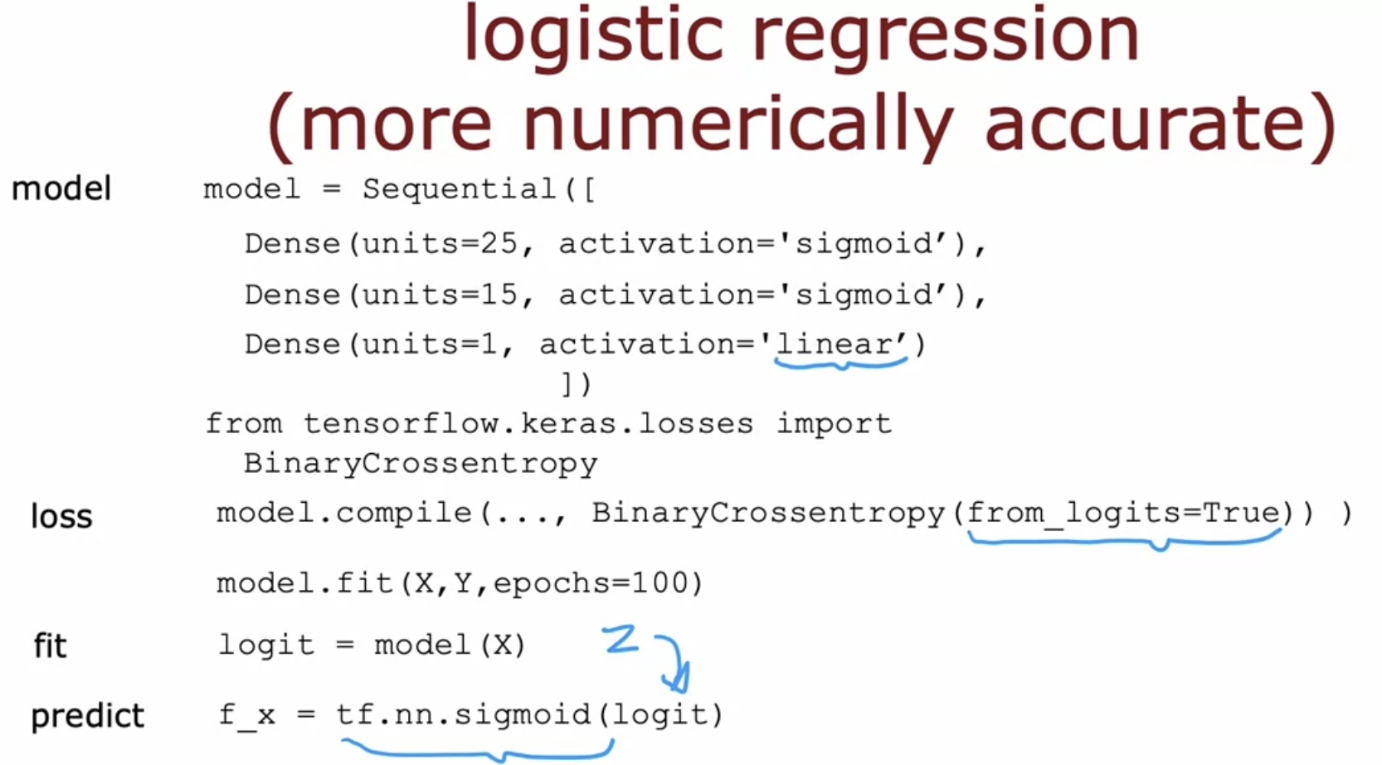

## **Applying this technique in SoftMax Regression**

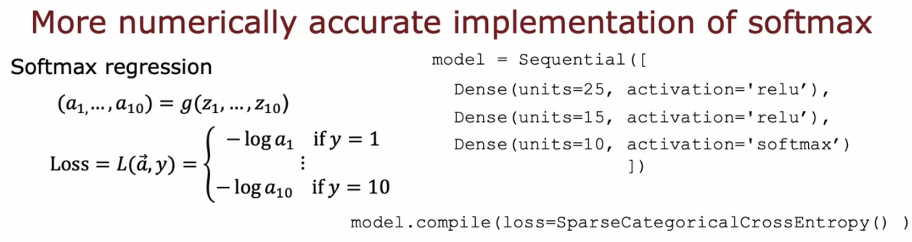

Apply the technique

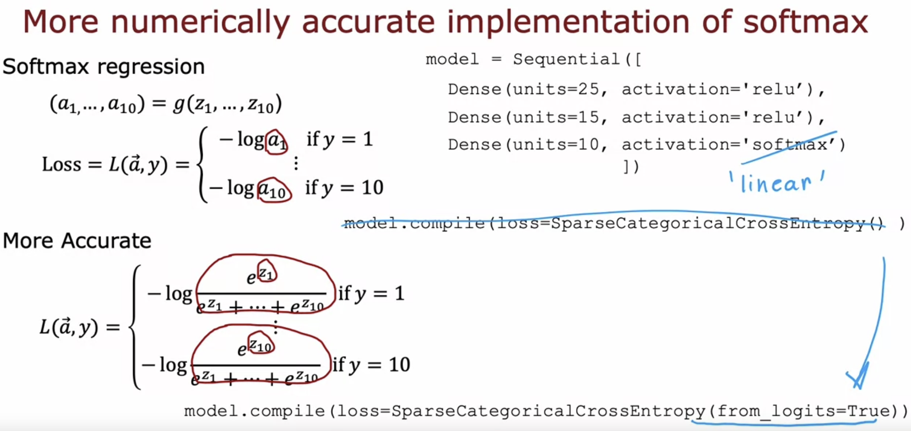

Just to give you some intuition for why TensorFlow might want to do this,   
it turns out if one of the z's (i.e for eg: z1) really small than e to negative small number becomes very small  
(or)   
if one of the z's (i.e for eg: z2) is a very large number, then e to the z can become a very large number and By rearranging terms, TensorFlow can avoid some of these very small or very large numbers and therefore come up with more accurate computation for the loss function.

Output layer 🡪 Linear Activation Function

Once again, these two pieces of code do pretty much the same thing, except that the version that is recommended is more numerically accurate, although unfortunately, it is a little bit harder to read as well.

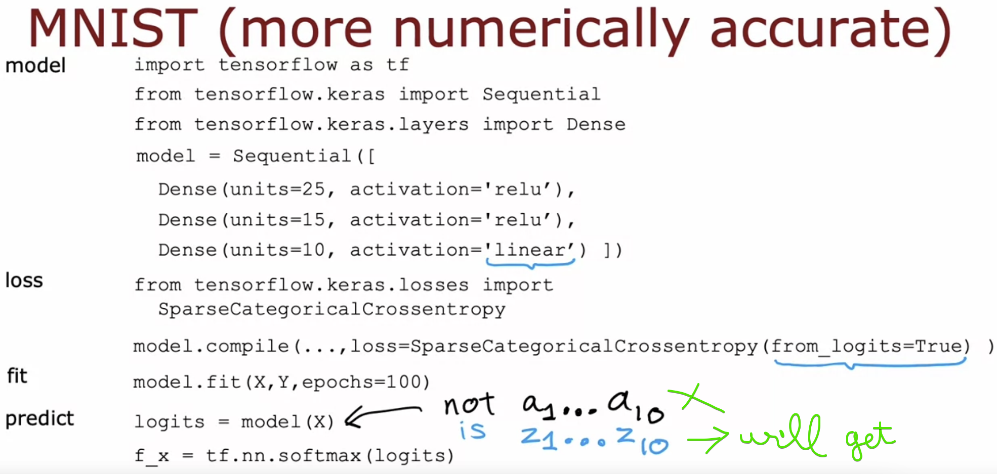

# **Classification with multiple outputs**

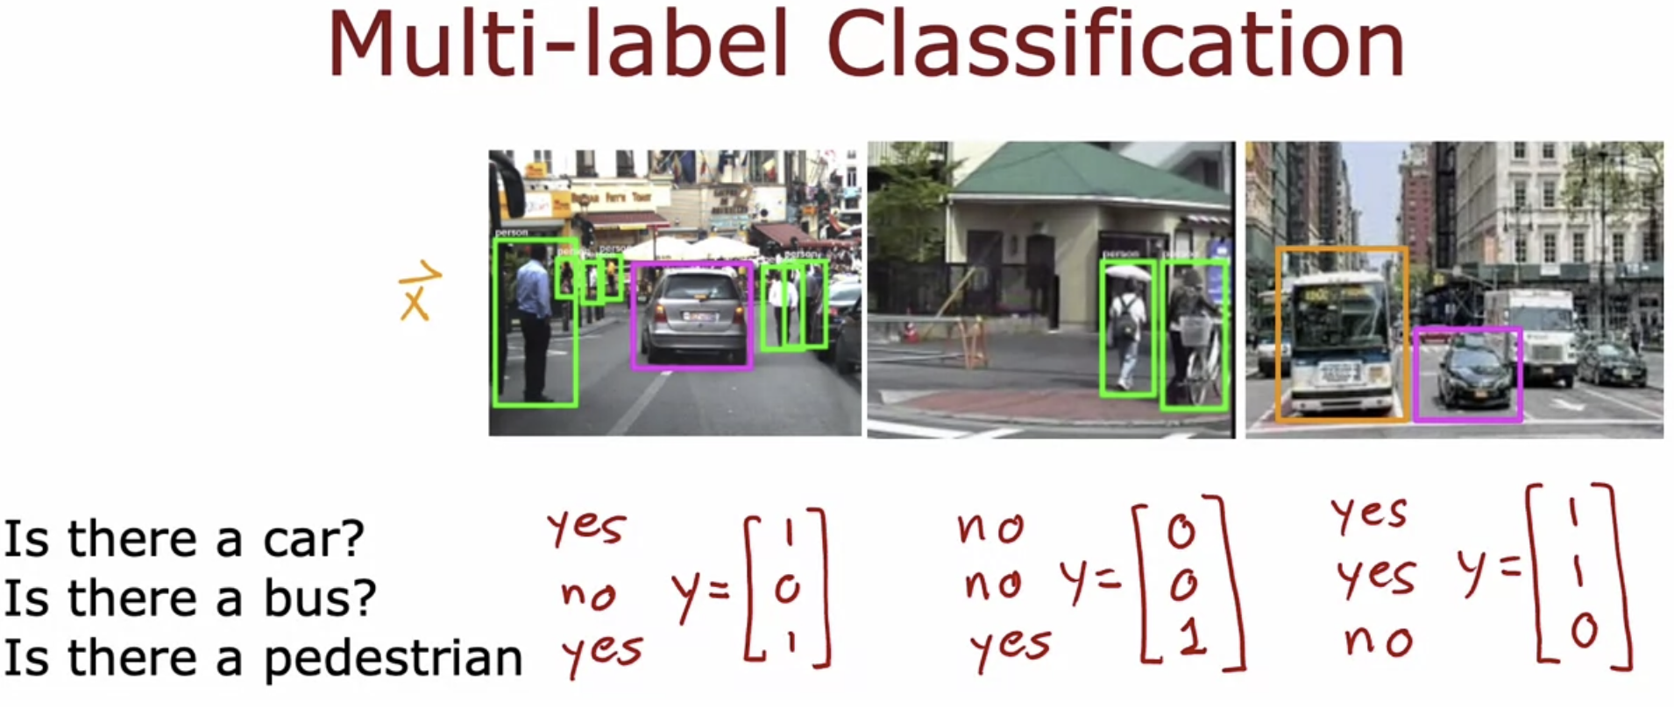

1st neural network 🡪 To detect car

2nd neural network 🡪 To detect bus

3rd neural network 🡪 To detect pedestrian

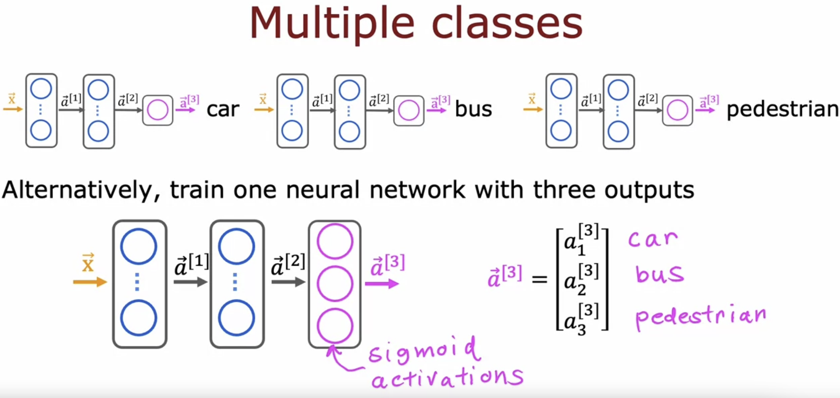

Now this final layer produces three output neurons which outputs a^3 (a vector of 3 numbers)

We can use sigmoid activation functions for each of these three nodes in the output layer.